1. Creating and Renaming Files/Directories Create a directory named test_dir using mkdir. Inside test_dir, create an empty file called example.txt. Rename example.txt to renamed_example.txt using mv

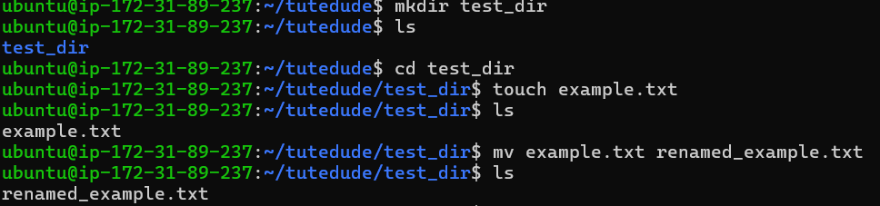

**Explanation:**

* mkdir test_dir: Creates a new directory.
* touch example.txt: Creates an empty file.
* mv example.txt renamed_example.txt: Renames the file.

2. Viewing File Contents Use cat to display the contents of /etc/passwd. Display only the first 5 lines of /etc/passwd using head. Display only the last 5 lines of /etc/passwd using tail.

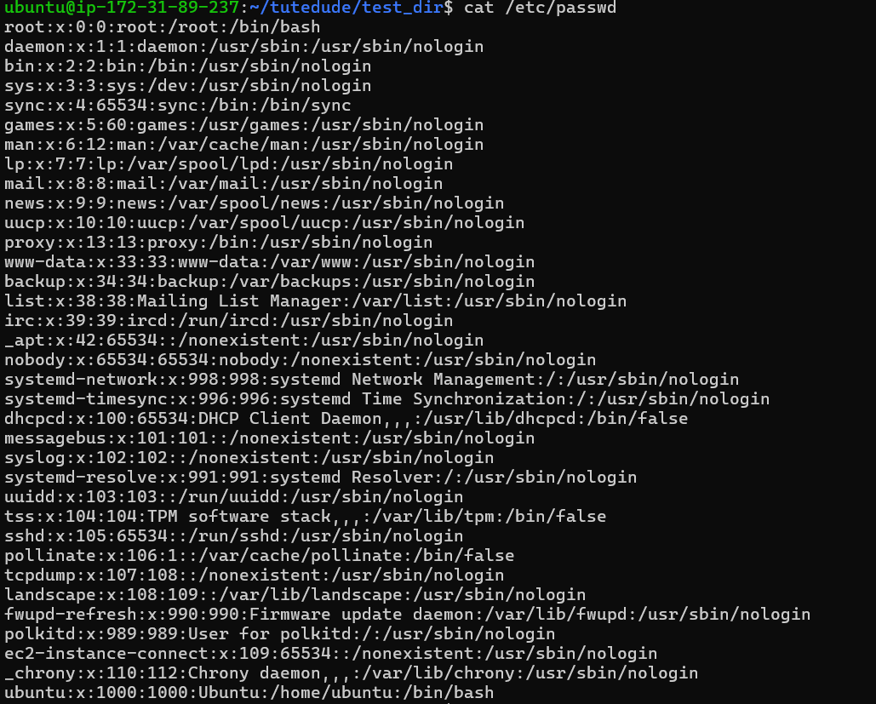

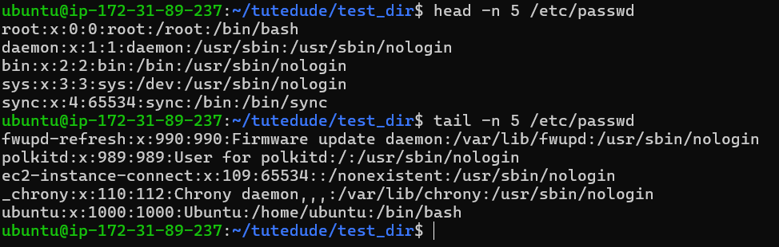

**Explanation:**

* cat: Displays full file content.
* head -n 5: Shows first 5 lines.
* tail -n 5: Shows last 5 lines.

3.Searching for Patterns:

Use grep to find all lines containing the word "root" in /etc/passwd.



4. Zipping and Unzipping

Compress the test_dir directory into a file named test_dir.zip using zip.

Unzip test_dir.zip into a new directory named unzipped_dir.

**Explanation:**

* zip -r: Compresses test_dir recursively.
* unzip: Extracts into unzipped_dir.

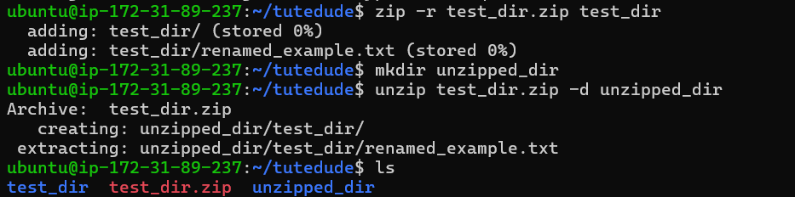

5. Downloading Files

Use wget to download a file from a URL [File Examples Download](https://file-examples.com/)

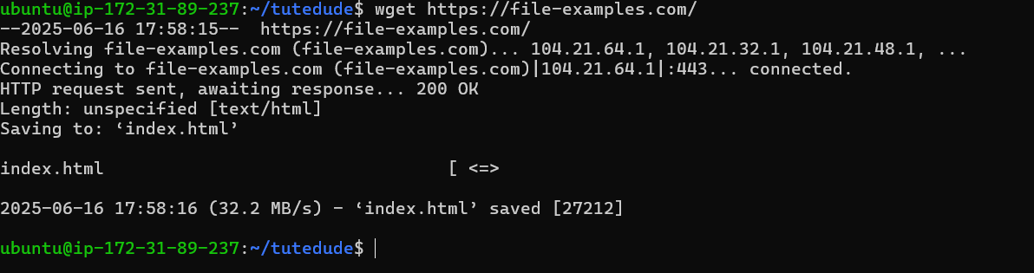

6. Changing Permissions

Create a file named secure.txt and change its permissions to read-only for everyone using chmod.

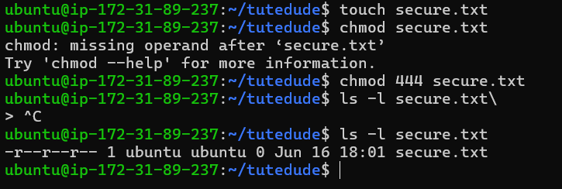

7. Working with Environment Variables

Use export to set a new environment variable called MY_VAR with the value "Hello, Linux!".

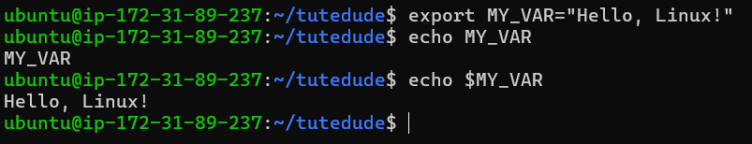

**Explanation:**

* export: Sets a new environment variable.
* echo $MY_VAR: Prints the variable value.